Yield Trend & Stability Analyses

S. Hadasch, P. Schmidt & H.-P. Piepho

1 Februar 2018

### Rawdata

The rawdata should be formatted like this:

head(dat)

## Y tj xj L Env G Rep Group Yield  
## 1 2001 2001 1980 Barisal 2001-Barisal BR10 1 Long 3.500000  
## 2 2001 2001 1980 Comilla 2001-Comilla BR10 1 Long 5.011047  
## 3 2001 2001 1980 Gazipur 2001-Gazipur BR10 1 Long 4.280233  
## 4 2001 2001 1980 Rajshahi 2001-Rajshahi BR10 1 Long 4.480000  
## 5 2001 2001 1980 Rangpur 2001-Rangpur BR10 1 Long 3.176419  
## 6 2001 2001 1980 Satkhira 2001-Satkhira BR10 1 Long 6.885814

Where $Y$ and $t_{j}$ both represent the year of the trial, while the former is defined as a factor and the latter as an integer variables. $x_{j}$ is the year the respective genotype was released, $L$ is the location, $Env$ is the year-location-combination, $G$ is the genotype, $Rep$ is the replicate, $Group$ is the ??group?? and $Yield$ is the yield.

str(dat)

## 'data.frame': 7635 obs. of 9 variables:  
## $ Y : Factor w/ 15 levels "2001","2002",..: 1 1 1 1 1 1 1 2 2 2 ...  
## $ tj : int 2001 2001 2001 2001 2001 2001 2001 2002 2002 2002 ...  
## $ xj : int 1980 1980 1980 1980 1980 1980 1980 1980 1980 1980 ...  
## $ L : Factor w/ 9 levels "Barisal","Bhanga",..: 1 3 4 6 7 8 9 1 3 4 ...  
## $ Env : Factor w/ 116 levels "2001-Barisal",..: 1 2 3 4 5 6 7 8 9 10 ...  
## $ G : Factor w/ 29 levels "BR10","BR11",..: 1 1 1 1 1 1 1 1 1 1 ...  
## $ Rep : Factor w/ 3 levels "1","2","3": 1 1 1 1 1 1 1 1 1 1 ...  
## $ Group: Factor w/ 5 levels "Aromatic","Long",..: 2 2 2 2 2 2 2 2 2 2 ...  
## $ Yield: num 3.5 5.01 4.28 4.48 3.18 ...

summary(dat)

## Y tj xj L   
## 2015 : 761 Min. :2001 Min. :1973 Gazipur : 993   
## 2014 : 717 1st Qu.:2005 1st Qu.:1988 Rangpur : 990   
## 2012 : 696 Median :2010 Median :1994 Rajshahi: 984   
## 2013 : 591 Mean :2009 Mean :1994 Comilla : 981   
## 2011 : 543 3rd Qu.:2013 3rd Qu.:2003 Sonagazi: 978   
## 2010 : 510 Max. :2015 Max. :2014 Satkhira: 888   
## (Other):3817 (Other) :1821   
## Env G Rep Group   
## 2015-Comilla : 96 BR10 : 348 1:2544 Aromatic:1392   
## 2015-Gazipur : 96 BR11 : 348 2:2546 Long :1250   
## 2015-Kustia : 96 BR22 : 348 3:2545 Medium :2583   
## 2015-Rajshahi: 96 BR23 : 348 Short : 941   
## 2015-Rangpur : 96 BR25 : 348 Stress :1469   
## 2015-Satkhira: 96 BR3 : 348   
## (Other) :7059 (Other):5547   
## Yield   
## Min. :0.200   
## 1st Qu.:3.064   
## Median :3.914   
## Mean :3.923   
## 3rd Qu.:4.776   
## Max. :8.800   
##

### Stage I: genotype means per environment

In order to do any yield trend and/ot yield stability analyses, genotype mean yields per environment are required.

[...]

str(dat3)

## 'data.frame': 2546 obs. of 11 variables:  
## $ Env : Factor w/ 116 levels "2001-Barisal",..: 1 2 3 4 5 6 7 8 9 10 ...  
## $ Y : Factor w/ 15 levels "2001","2002",..: 1 1 1 1 1 1 1 2 2 2 ...  
## $ tj : int 2001 2001 2001 2001 2001 2001 2001 2002 2002 2002 ...  
## $ xj : int 1980 1980 1980 1980 1980 1980 1980 1980 1980 1980 ...  
## $ L : Factor w/ 9 levels "Barisal","Bhanga",..: 1 3 4 6 7 8 9 1 3 4 ...  
## $ G : Factor w/ 29 levels "BR10","BR11",..: 1 1 1 1 1 1 1 1 1 1 ...  
## $ Group : Factor w/ 5 levels "Aromatic","Long",..: 2 2 2 2 2 2 2 2 2 2 ...  
## $ arimean: num 3.87 4.92 3.97 4.06 3.48 ...  
## $ adjmean: num 3.87 4.92 3.97 4.06 3.48 ...  
## $ se : num 0.13 0.237 0.18 0.199 0.23 ...  
## $ w : num 58.9 17.9 30.9 25.3 18.9 ...

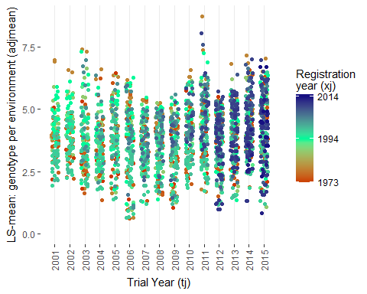

### Stage II: Shukla

require(asreml)  
  
shuklamod <- asreml(fixed = adjmean ~ xj + tj,  
 random = ~ G + L + Y + L:G + Y:G + Y:L + at(G):Env,   
 ran.order = "user",  
 weights = w,  
 family = asreml.gaussian(dispersion=1.0),  
 control = asreml.control(pworkspace=8e10 ,  
 workspace=8e8,   
 maxiter=100),  
 data = dat3)

The variances can be accessed via summary(shuklamod)$varcomp[2:3]. After some formatting we find:

## Variety Estimate StdErr  
## 1 BR10 0.3722 0.0617  
## 2 BR11 0.4088 0.0675  
## 3 BR22 0.2892 0.0493  
## 4 BR23 0.2107 0.0390  
## 5 BR25 0.2471 0.0439  
## 6 BR3 0.3701 0.0611  
## 7 BR4 0.1754 0.0342  
## 8 BR5 0.2756 0.0479  
## 9 BRRI dhan30 0.2042 0.0369  
## 10 BRRI dhan31 0.2292 0.0423  
## 11 BRRI dhan32 0.3163 0.0544  
## 12 BRRI dhan33 0.4119 0.0674  
## 13 BRRI dhan34 0.2056 0.0390  
## 14 BRRI dhan37 0.1864 0.0364  
## 15 BRRI dhan38 0.1101 0.0243  
## 16 BRRI dhan39 0.4597 0.0735  
## 17 BRRI dhan40 0.2126 0.0412  
## 18 BRRI dhan41 0.3328 0.0592  
## 19 BRRI dhan44 0.1310 0.0337  
## 20 BRRI dhan46 0.2405 0.0557  
## 21 BRRI dhan49 0.1369 0.0451  
## 22 BRRI dhan51 0.0865 0.0389  
## 23 BRRI dhan52 0.1147 0.0474  
## 24 BRRI dhan53 0.2416 0.0857  
## 25 BRRI dhan54 0.3365 0.1217  
## 26 BRRI dhan56 0.4046 0.1357  
## 27 BRRI dhan57 0.7264 0.2218  
## 28 BRRI dhan62 1.3604 0.5987  
## 29 BRRI dhan66 0.4207 0.3067

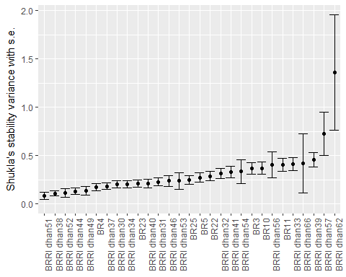

### Stage II: Factor-Analytic Model

FAmod <- asreml(fixed = adjmean ~ xj + tj,  
 random = ~ G + L + Y + L:G + Y:G + fa(G):Env,  
 ran.order = "user",  
 weights = w,  
 family = asreml.gaussian(dispersion=1.0),  
 control = asreml.control(pworkspace=8e10 ,  
 workspace=8e8,   
 maxiter=100),  
 data = dat3)

The variances and lambdas can again be accessed via summary(FAmod)$varcomp[2:3]. After some formatting we find:

## Variety Var_Est Var_SE Lambda_Est Lambda_SE  
## 1 BR10 0.2572 0.0466 1.1690 0.0897  
## 2 BR11 0.2752 0.0495 1.1910 0.0919  
## 3 BR22 0.2853 0.0483 0.9312 0.0810  
## 4 BR23 0.2072 0.0385 0.8664 0.0714  
## 5 BR25 0.2496 0.0434 0.7442 0.0713  
## 6 BR3 0.3795 0.0617 0.8230 0.0849  
## 7 BR4 0.1762 0.0343 0.9402 0.0731  
## 8 BR5 0.2307 0.0398 0.5244 0.0657  
## 9 BRRI dhan30 0.1910 0.0347 0.9240 0.0741  
## 10 BRRI dhan31 0.2073 0.0393 0.9937 0.0770  
## 11 BRRI dhan32 0.3217 0.0544 0.8690 0.0817  
## 12 BRRI dhan33 0.4328 0.0688 0.7148 0.0870  
## 13 BRRI dhan34 0.1843 0.0339 0.5410 0.0613  
## 14 BRRI dhan37 0.1458 0.0293 0.5593 0.0577  
## 15 BRRI dhan38 0.0950 0.0209 0.5986 0.0535  
## 16 BRRI dhan39 0.4836 0.0757 0.7847 0.0913  
## 17 BRRI dhan40 0.2182 0.0414 0.8431 0.0739  
## 18 BRRI dhan41 0.3405 0.0592 0.7925 0.0840  
## 19 BRRI dhan44 0.1231 0.0322 0.9022 0.0743  
## 20 BRRI dhan46 0.2495 0.0566 0.8196 0.0949  
## 21 BRRI dhan49 0.1254 0.0420 0.9538 0.0926  
## 22 BRRI dhan51 0.0766 0.0372 0.9833 0.0954  
## 23 BRRI dhan52 0.0748 0.0364 1.0118 0.0966  
## 24 BRRI dhan53 0.2743 0.0923 0.8234 0.1444  
## 25 BRRI dhan54 0.3245 0.1174 1.0629 0.1567  
## 26 BRRI dhan56 0.4237 0.1372 0.7005 0.1691  
## 27 BRRI dhan57 0.7333 0.2166 0.4757 0.2024  
## 28 BRRI dhan62 0.7320 0.3431 -0.1737 0.3009  
## 29 BRRI dhan66 0.4454 0.3096 0.7341 0.3247